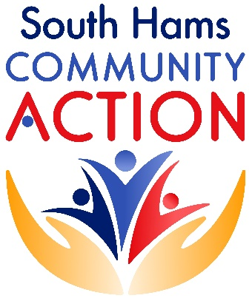

**MINI CONFERENCE  
SOUTH HAMS CARING ORGANISATIONS**

**HYBRID MEETING**

This mini conference will bring together caring organisations from across the South Hams. Invited speakers are coming to share information about their organisations and answer questions.

We can all acknowledge that South Hams is a large area, encompassing some small and large organisations who are doing brilliant work serving their communities. South Hams Community Action (formerly South Hams CVS) has been successfully running two local alliance meetings throughout the year. We’ve been asked to set up a South Hams Wide District Alliance Meeting, to enable our caring organisations to share learning, to network and for support.

South Hams Community Action would also like to bring organisations together to increase the ability to bring much needed funding into the South Hams area. We would like to take the opportunity during this mini-conference to discuss the possibility of a South Hams District Alliance Meeting or something similar, and to make future plans.

**TUESDAY 21ST NOVEMBER 2023   
FOLLATON HOUSE, TOTNES  
Plymouth Road, Totnes TQ9 5NB**

**AGENDA**

10.00-10.15 – Arrive, tea/coffee

10.15-10.30 – Introductions

10.30-11.00 – Claire Hill from Totnes Caring

11.00-11.30 – Liz Hitchins/Steven Parker Davidson from Four Rivers Dementia Alliance

11.30-11.45 –Tea Break

11.45-12.15 – Suzie Walters-Jeffries from Devon Carers

12.15-12.30 – Jackie Wesley - Update from South Hams Community Action

12.30 -13.00 – Discussion about District Wide Alliance Meeting (twice yearly learning/networking meeting).

13.00-14.00 – Light Lunch and Networking

There is free parking at Follaton House, Totnes.

Please register your interest in attending this mini-conference and how many people will be attending from your organisation. Please specify if you will be attending the event in person or if you require a Microsoft Teams invite. Please respond to [admin@southhamscvs.org.uk](mailto:admin@southhamscvs.org.uk).